Abstract title
F. Author¹*, S. Author²
¹First affiliation
²Second affiliation
³Third affiliation
*e-mail: presenting author e-mail address

Type the body of the abstract text. The abstract should not exceed ONE PAGE of text, references, tables and figures. Abstracts exceeding this limit may be cut without consideration of content after the first page. If the figure is present, please insert figures with resolution 300 dpi for colour and 600 dpi for grayscale mode. Please name the file in the following format: Last name of the presenting author_ type of presentation.docx (or .doc) (e.g. Author_Oral.docx).
Second paragraph blank text. Lorem ipsum dolor sit amet, consectetur adipiscing elit, sed do eiusmod tempor incididunt ut labore et dolore magna aliqua. Ut enim ad minim veniam, quis nostrud exercitation ullamco laboris nisi ut aliquip ex ea commodo consequat. Duis aute irure dolor in reprehenderit in voluptate velit esse cillum dolore eu fugiat nulla pariatur. Excepteur sint occaecat cupidatat non proident, sunt in culpa qui officia deserunt mollit anim id est laborum.
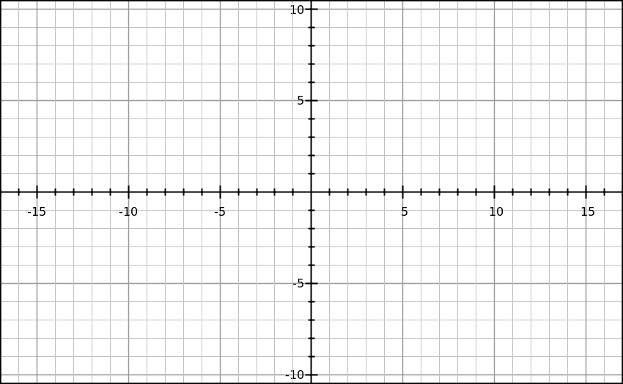
Fig. 1 Figure 1 description.
In this¹ part of text we present² the use of references³. References style is Nature⁴.
Acknowledgements: Authors would like to thank A. Bianco, E. Busetto and I. Cudin from Synchrotron Elettra, Trieste for beamline optical design optimization and support during the design period.
References
1. For Example, R., Nishida, S. & Johnston, A. An adaptable metric shapes perceptual space. Curr. Biol. 26, 1911–1915 (2016).
2. For Example Tesla Motors master plan (just between you and me). Tesla Blog https://www.tesla.com/blog/secret-tesla-motors-master-plan-just-between-you-and-me (2006).
3. For Example V. Structure databases. in Bioinformatics (eds. Baxevanis, A. D. & Ouellette, B. F. F.) 83–109 (Wiley-Interscience, 2001).
4. For Example & Russell, D. W. Molecular cloning: a laboratory manual. (CSHL Press, 2001)
LIMIT ONE PAGE

